Empty log-in screen.

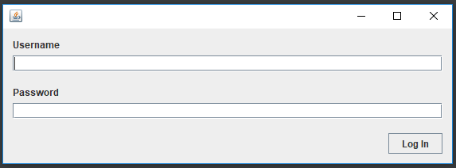

Enter invalid log-in details and view the resultant error message.

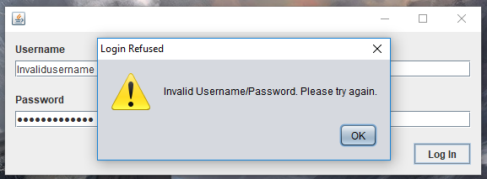

Driver core interface.

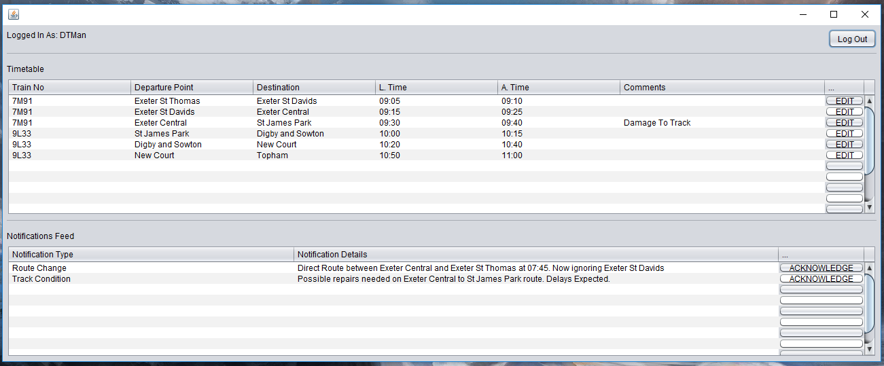

Edit comment interface. Enter comment details and submit the modified comment record for the selected journey.

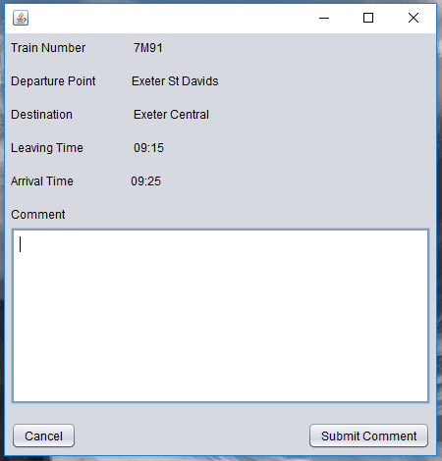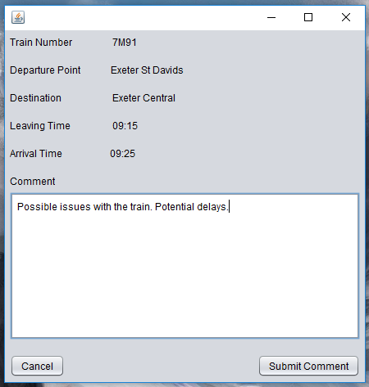

View the new comments added to the previously selected journey.

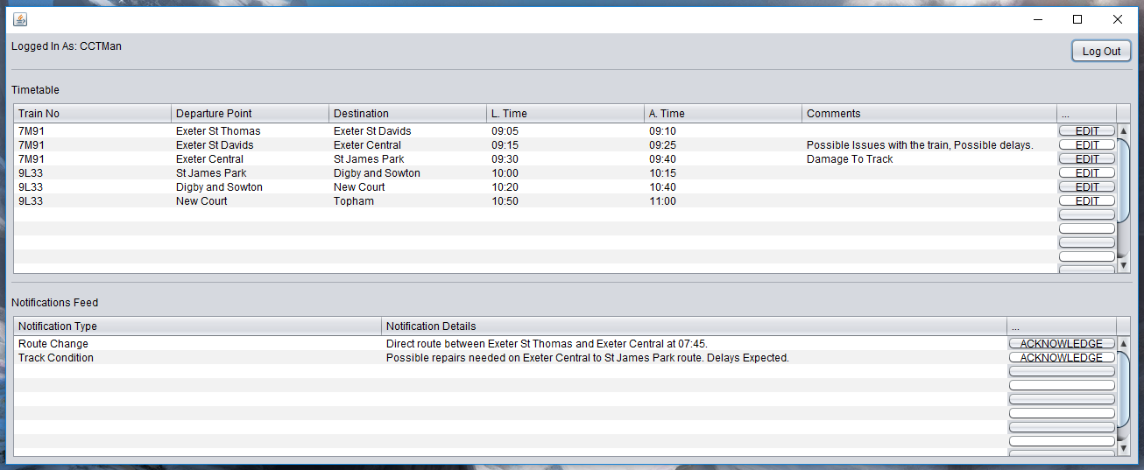

Cabin crew core interface.

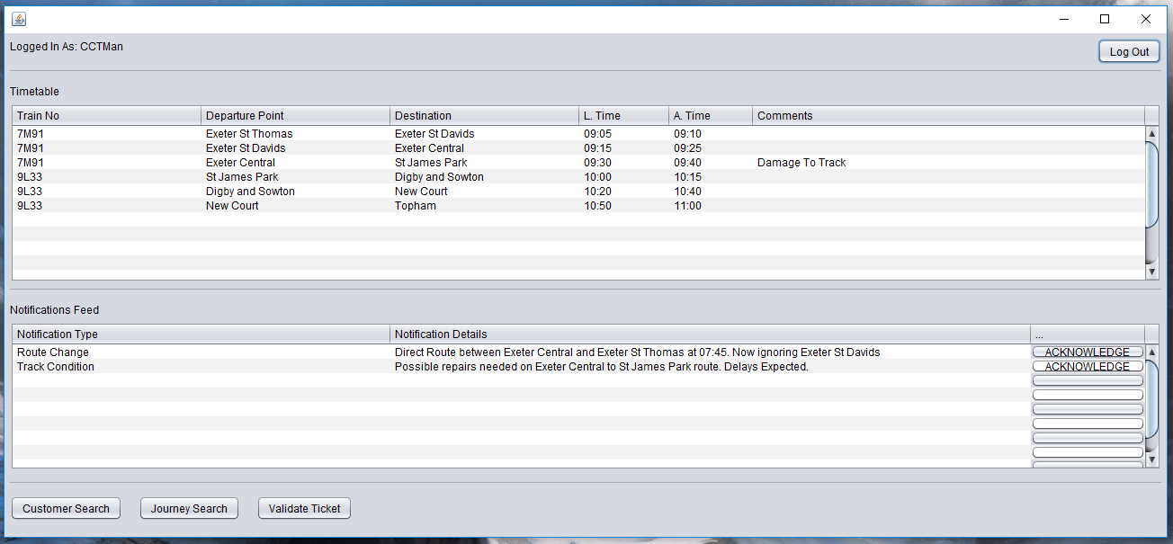

Click the “Acknowledge” button in the Notifications feed to remove a notification from the feed.

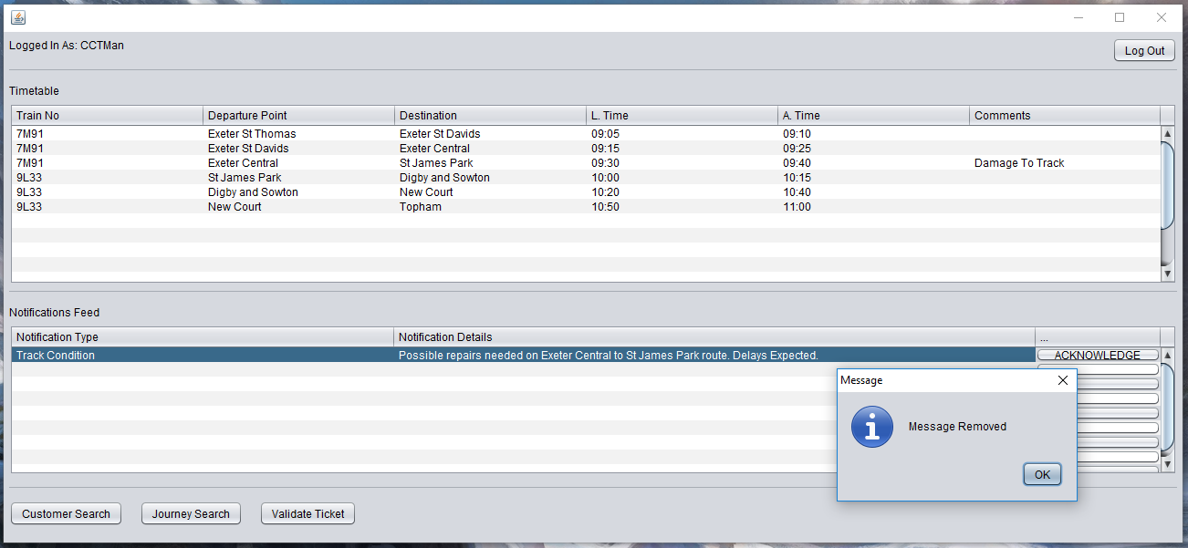

Empty journey search interface.

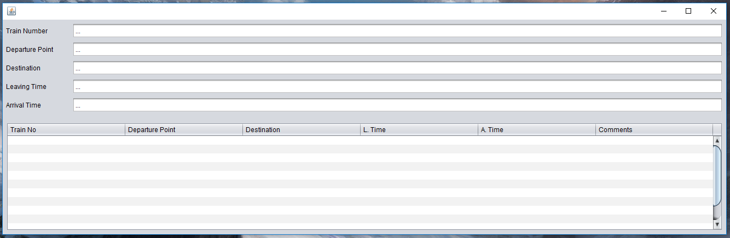

Enter the departure point of “Exeter Central” and view the returned journey record results.

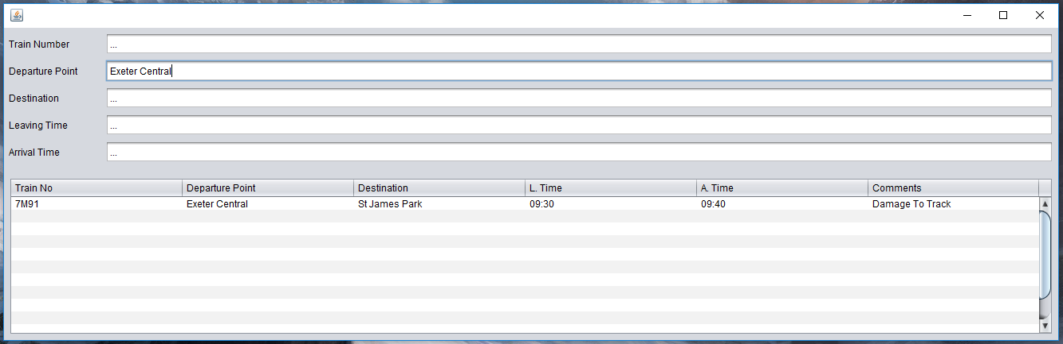

Empty customer search interface.

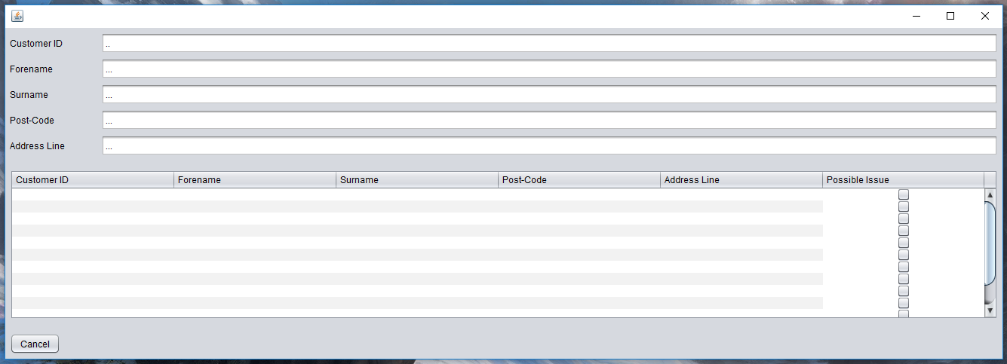

Enter a customer ID of “33” and view the returned customer record results. Tick the “Possible Issue” option to flag the customer as a potential problem.

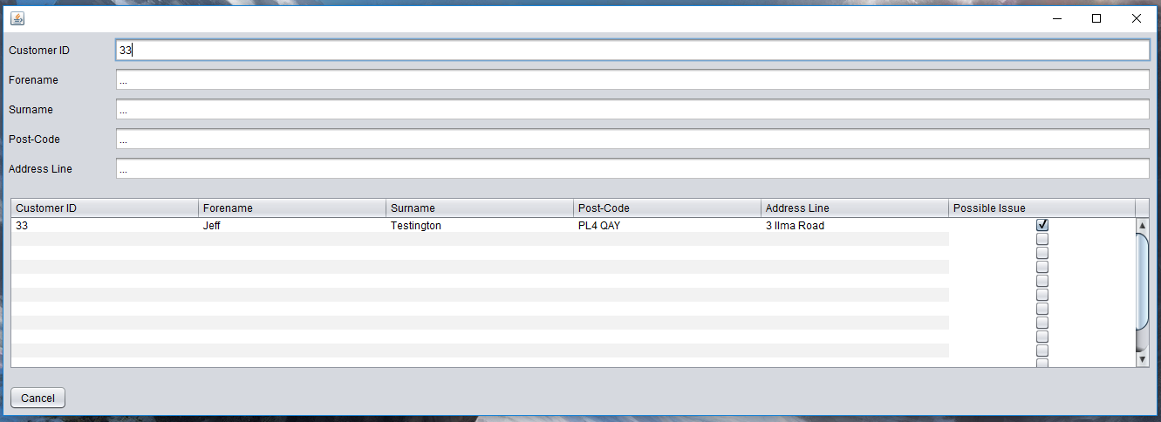

Ticket validation interface. Enter the ticket number “33086592” and click “Validate”.

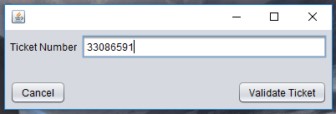

If the ticket number is valid, an alert will display saying “Ticket is valid”.

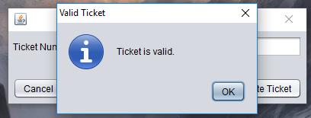

If the ticket number is invalid, an alert will display saying “Ticket is NOT valid”.

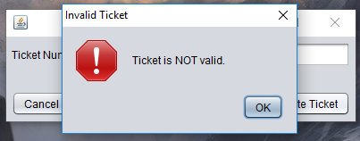

If no ticket number is entered, an alert will display saying “No ticket number was entered. Please enter a ticket number.

